Worksheet 3
RELATIVE DATING WORKSHEET ___________________________________________________________
1. Sedimentary Layers – the Law of Superposition
What is the law of Superposition?
_____________________________________________________________________________________
_____________________________________________________________________________________
PRACTICAL – MAKING SEDIMENTARY LAYERS
Design a model to describe sedimentary layers.
Labelled Drawing
a | Which layer went in first?
b | Which layer went in last?
c | Which layer is the “oldest” in the sequence?
d | What was the overall sequence of events if there was no disturbance (from oldest to youngest)?

This is the law of Superposition.
2. THE USE OF FOSSILS – DATING
Fossils have been used to date rocks as they are time markers – many species lived at a particular time and later became extinct. As you saw from (1) above, the deepest rocks are usually the oldest, therefore the fossils found at the base of a rock sequence that has not been disturbed will be the oldest. Complete the following practical.
A. Place the fossils in the appropriate geological time period on the card.
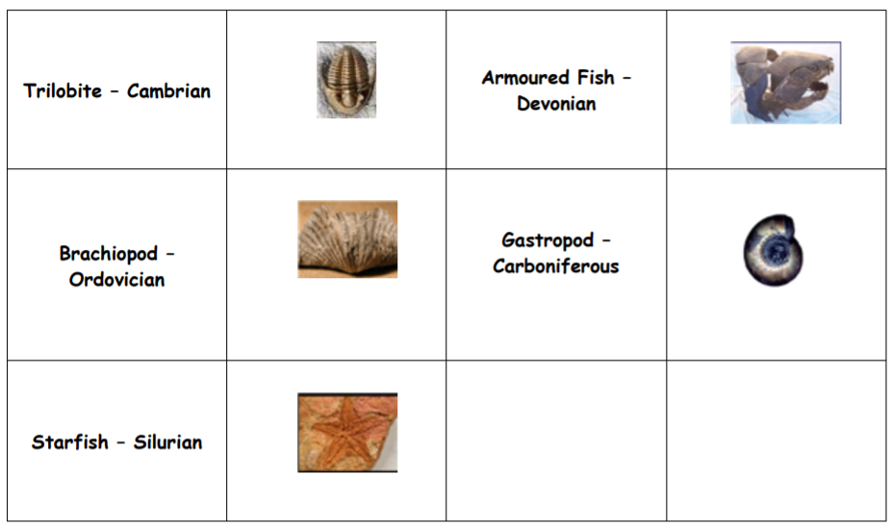
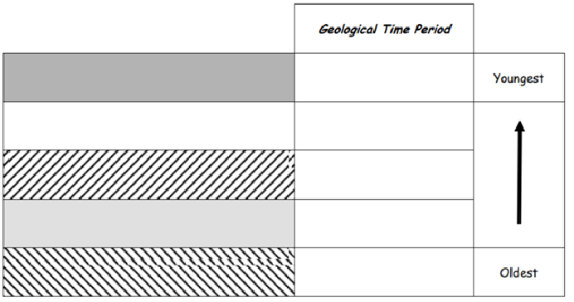
a | Which fossil layer is the oldest (name the geological period)?
b | Which fossil layer is the youngest (name the geological period) ?

We can use fossils to date rocks. Is this an absolute age (we know how many years ago the fossil lived?) or is it a relative date (we know one is older than the other, but not how old they are?).
_____________________________________________________________________________________
_____________________________________________________________________________________
_____________________________________________________________________________________
B. Elaboration: Place an extra Trilobite within the Ordovician, and an extra Starfish in the Devonian.
a | At the end of which geological time period did the Starfish become extinct ?
b | During which geological time period did the Starfish evolve and first appear ?
c | During which geological time period did the Trilobite evolve and first appear ?
d | At the end of which geological time period did the Trilobite become extinct ?

How does knowing when a fossil lived and became extinct help us date rocks?
_____________________________________________________________________________________
_____________________________________________________________________________________
_____________________________________________________________________________________
3. HOW DO ROCKS DEFORM and WHAT IS THE CONSEQUENCE FOR THE AGE OF THE LAYERS ?
Rocks can deform in two ways due to pressures and temperatures within the Earth: (1) soft (ductile) into folds; or (2) brittle – these are faults
Let us see the end result of ductile deformation.
Ingredients Three different coloured layers of plasticine

A. Push the plasticine with equal force from each side until it curves upwards like the drawing below - draw in colour and label the layers A, B, C from the oldest upwards.
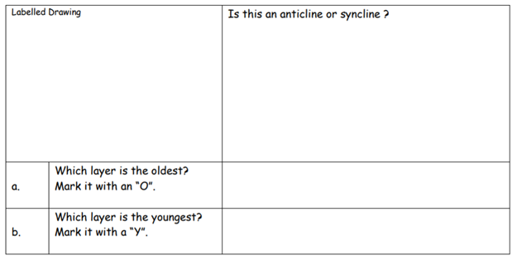
B. Push the plasticine further until the fold is overturned as the drawing below – draw and label the layers as above marking the oldest with “O” and the youngest with “Y”.
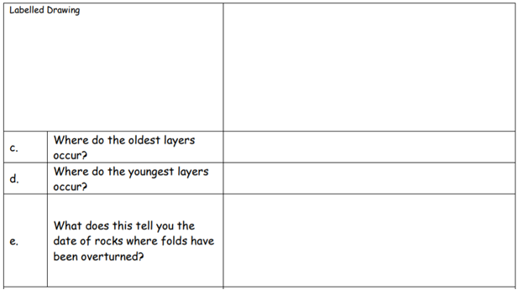
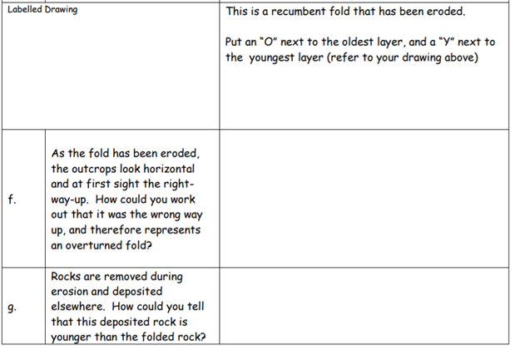
Model how sedimentary rock layers are disturbed (eg Tilting, faults, Folding, intrusions…)

