Name: Grade 8 Section: ___Date:______________

SCIENCE SKILL 1: Graphing and Graph analysis

OVERVIEW

Our activity is based upon the news paper article that was published in April 11, 2007 by NASA, and the title is NASA Predicts Non-Green Plants on Other Planets. On the news paper articles it talks about scientists predicting that some planets might have mostly non-green plants, such as yellow or red-dominant plants. This idea was developed by researchers and scientists looking at the changes in that light through different atmospheres, and from the results they identified the colors that would be most favorable for photosynthesis on other planets. Each planet will have different dominant colors for photosynthesis, based on the planet’s atmosphere where the most light reaches the planet’s surface.

On Earth, Kiang and colleagues surveyed light absorbed and reflected by plants and some bacteria during photosynthesis, and from that they found out that organisms that live in different light environments absorb the light colors that are most available. It explained photosynthesis that happens in Earth by saying that the Sun has a specific distribution of colors of light, emitting more of some colors than others. Gases in Earth's air also filter sunlight, absorbing different colors.

As a result, more red light particles reach Earth's surface than blue or green light particles, so plants use red light for photosynthesis. Carl Pilcher who is a director of the NAI at NASA Ames said "This work broadens our understanding of how life may be detected on Earth-like planets around other stars, while simultaneously improving our understanding of life on Earth." Also Victoria Meadows who is an astronomer who is head of VPL said “This work will help guide designs for future space telescopes that will study extra-solar planets, to see if they are habitable, and could have alien plants.”

Check the following link for the article:

https://www.nasa.gov/centers/goddard/news/topstory/2007/spectrum_plants.html

Claim:

__________________________________________________________________________________________________________________________________________________________________________________________________________________________________________

Design

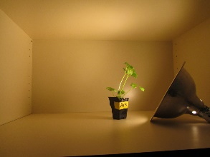 | 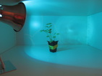 | 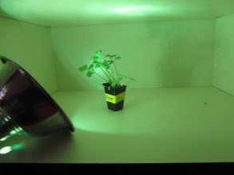 | 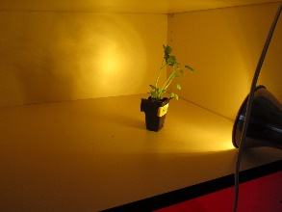 | 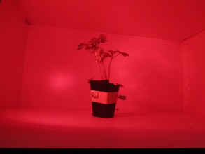
white | blue | green | yellow | red
Materials:
- 5 celery plants
- 4 40W light bulbs (1 blue, 1 white, 1 green, 1 yellow)
- Water
- Light Shields
Variables:
- Independent: Light Color
- Dependent: Rate of photosynthesis
- Control Variables: Type of Plant, Amount of Water, Ambient Air Content, Amount of Light
Procedure:
1. Make individual cubbies for each plant so that light exposure is controlled
2. Place one plant in each cubby
3. Expose each plant to a 50W light bulb, each of a different cover
4. At 7:30 each day, measure the mass of the plants and record in data table
5. Water with 50ml of water every day at 8:00
6. Repeat 1-5 for a week
7. Record data and analyze to determine the relative health of the plants based on the color of light exposed.

Data Collection:

The table below represents our collection of raw data every day for up to 8 days total.
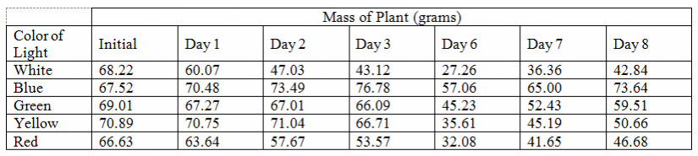

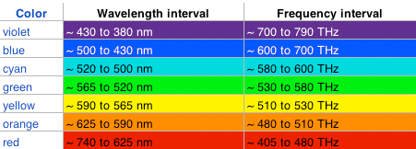
Photo Credit: http://www.relativitycalculator.com/Albert_Michelson_Part_I.shtml

Data Evaluation:

DRAW THE GRAPH ON THE GRAPH PAPER AND PASTE IT HERE.

The mass of a plant is directly related to its rate of photosynthesis, which is necessary for it to live and to grow.
The equation of photosynthesis is: 6CO2 + 6H2O + Energy --> C6H12O6 + 6O2.
In this case, energy is the light energy given off by the light bulb. Light energy travels in waves. Each color of light has a different wavelength which gives it a distinct color. The chart below shows the wavelengths of each color of light in order of shortest to longest.

Photo Credit: http://www.relativitycalculator.com/Albert_Michelson_Part_I.shtml

ANALYZE THE RESULTS AND DRAW CONCLUSIONS BASED ON THE GIVEN DATA AND YOUR RESEARCH.

RUBRIC

 | Did Not Meet  Expectations | Met Expectations | Exceeded Expectations | Reflection
Labeling | Axes were not labeled according to the given data. Based on the independent and dependent variables in the data. Title was not labeled according to the data. | Axes were labeled according to the given data. The x-axis was labeled as the independent variable and the y axis was labeled as the dependent variable. The graph is title is related to the data but does not fully represent what the data conveys. | Axes were labeled according to the given data. The x-axis was labeled as the independent variable and the y axis was labeled as the dependent variable. The graph title is related to the data and fully represents what the data conveys.
Scale | Scaling on both x and y axes were not based on the patterns presented by the data (i.e counting by 2’s, 5’s, 10’s etc..) The spacing between the numbers on the scale is nonexistent. | Scaling on both x and y axes were based on the patterns presented by the data (i.e counting by 2’s, 5’s, 10’s etc..) The spacing between the numbers on the scale is existent but not consistent throughout the graph. | Scaling on both x and y axes were based on the patterns presented by the data (i.e counting by 2’s, 5’s, 10’s etc…) The spacing between the numbers on the scale is existent and consistent throughout the graph.
Interpreting | Interpretation of the data represented is completely inaccurate and not detailed. | Interpretation of the data represented is completely accurate but not detailed. | Interpretation of the data represented is completely accurate and detailed.
Conclusion | Conclusion does not discuss the hypothesis | Conclusion discusses the hypothesis but does not discuss future recommendations | Conclusion discusses the hypothesis and discusses future recommendations

