Name: ___________________________ Worksheet Group 2 Date:______________________________
Fossils 101
Like buried treasure, they lie hidden from sight. Echoes of an ancient past, they whisper secrets and tell tales once lost to time.
Fossils are remnants or impressions of ancient organisms that are naturally preserved in stone.
While there are hundreds of fossil types, they are often grouped into two major categories:
Categories of fossils

Together, they form the fossil record, a primary account that tells the story of life on Earth through stone.
Fossilization, or the process of preserving organisms in stone, can occur in countless ways.
These methods are largely grouped depending on whether the organisms are altered during the fossilization process.
Fossilization that does not alter a specimen can help to preserve its original form and texture.
Among many methods, this group includes organisms that have been frozen, preserved in tar pits, and mummified.
One special case involves trapping organisms – oftentimes, insects – in amber.
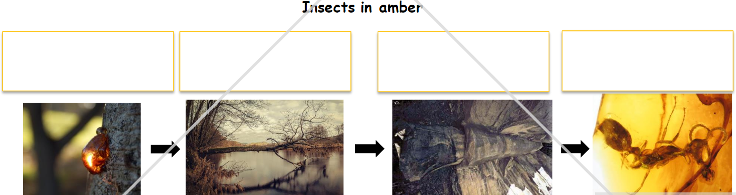

Other fossilization methods change the specimen as it is being preserved.
For instance, carbonization transforms soft tissues into thin, black films of carbon. In fact, countless layers of carbonized plant material create a well-known fossil fuel: coal.
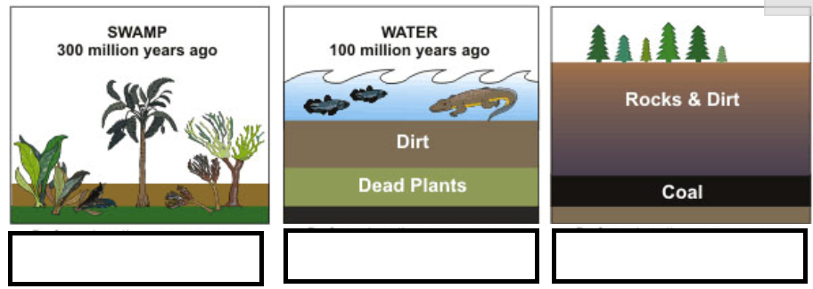

But one of the most common types of fossilization that changes a specimen is called “permineralization”.
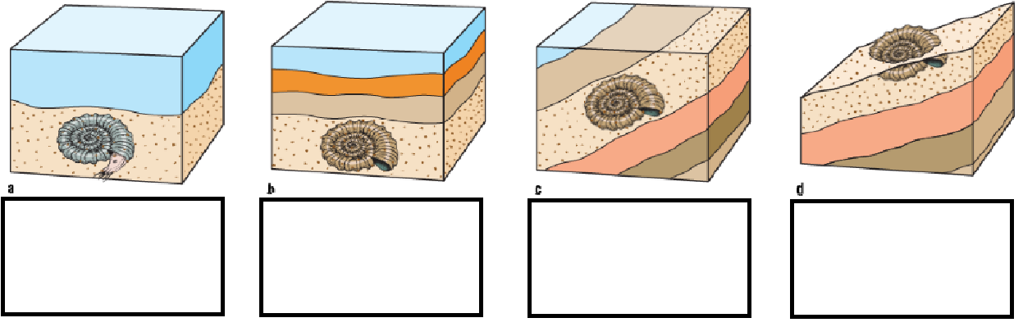
When conditions are right, fossilization can preserve crucial information about an organism. Describe why fossils are important for scientist to understand the present world.
___________________________________________________________________________________
___________________________________________________________________________________
___________________________________________________________________________________
___________________________________________________________________________________
___________________________________________________________________________________
___________________________________________________________________________________
___________________________________________________________________________________
___________________________________________________________________________________
___________________________________________________________________________________

